31st Annual

Yesteryear Regatta

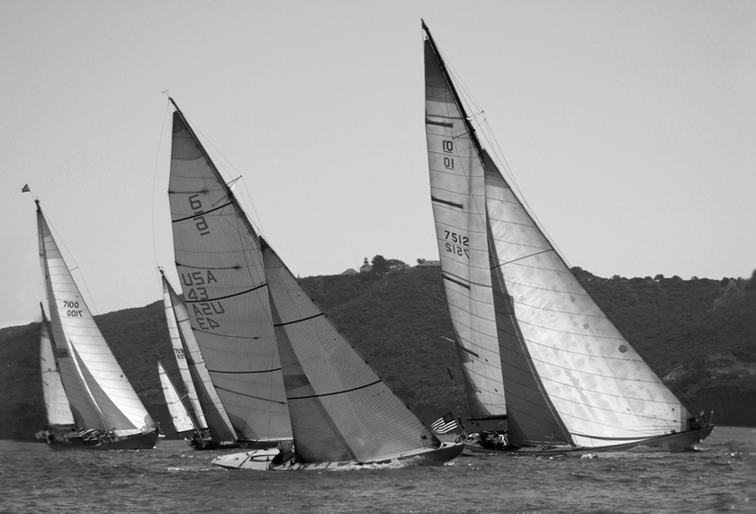

2004 Yesteryear

Saturday, May 14, 2005

Presented by

Ancient Mariners Sailing Society
31st Annual Yesteryear Regatta
May 14, 2005

Race Description

Eligibility
This Regatta is open to sailboats of ancient vintage and/or classic design. Neither yacht club nor previous racing experience is required to enter. AMSS reserves the right to reject and return applications for yachts that do not qualify.

Schedule of Events Saturday, May 14th 2005
- 0800 - 0900 Mandatory Registration & Packet pickup
- 0900 - 0915 Mandatory Skippers Meeting Southwestern Yacht Club
- 1150 First Signal
- Following Race Post race Party Fiddler’s Green
- Awards Presentation ASAP

Race Type & Course Description
The race is a pursuit type race. A long course and short course are offered. The long course consists of a 12nm San Diego Bay course that starts off the East end of Harbor Island, proceeds seaward to SD channel buoys #5 & #6 and then back in the bay off the East end of Harbor Island. The short course, for the Small Boat class, consists of a 9nm San Diego Bay course that starts and finishes at the same location as the long course.

Classes
For the purposes of scoring, the fleet will be subdivided into the following Six (6) classes:

- Classic Racing A
- Classic Racing B
- Sloops/Cutters
- Pacific Class
- Split Rigs & Gaffers
- Small Boat

Trophies
Trophies will be awarded to first, second and third place finishers in each class based on Corrected Time. Each entry will receive a participation memento. The below Perpetual trophies will record the winning yacht’s name.

- Dingus Perpetual Trophy Fastest yacht on Corrected Time
- Reliance Perpetual Trophy Fastest yacht on Elapsed Time
- Herreshoff Perpetual Trophy Fastest Herreshoff yacht on Corrected Time
- Sparkman & Stephens Perpetual Trophy Fastest Sparkman & Stephens yacht on Corrected Time
- Pacific Class Perpetual Trophy First Pacific Class yacht to finish
- International Rule Perpetual Trophy Fastest International Rule yacht on Corrected Time
- Luders 16 Perpetual Trophy First Luders 16 yacht to finish
- Kettenburg Perpetual Fastest Kettenburg yacht (non PC) on Corrected Time
- Turtle Trophy Last yacht to finish on Elapsed Time

Moorage
For guest moorage assistance contact AMSS Port Captain Scott Poorman at (619) 224-2751.
31st Annual Yesteryear Regatta
May 14, 2005

Application

(Complete All Sections)

Yacht Information

Boat Name:

Designer:

Year Built:

Hull Material:

Home Port:

Sail Number:

Type of Vessel:

Distinguishing Marks:

Length on Deck:

Length Waterline:

Working Sail Area:

Spinnaker: y/n Mz Staysail y/n

PHRF Rating:

AMSS Rating:

Comments:

Personal Information

Owner:

Address:

Telephone: (Home)

Telephone: (Work)

Email:

Entry Details

Entry Fee: $30 for AMSS members, $35 for non-AMSS members. Make check payable to AMSS.
Late entries shall be accompanied by an additional $5.

Entry Deadline: May 7th, 2005

Return Entry to:

Ancient Mariners Sailing Society
PO Box 6484
San Diego, CA 92166

Further Information: Contact AMSS Race Chairman Doug Jones at (619) 294-2244

Fill out other side

31st Annual Yesteryear Regatta

May 14, 2005

Liability & Photo Release

(All participants must complete & sign prior to Skipper’s Meeting)

YACHT NAME: CF/Document NUMBER:

TO: SOUTHWESTERN YACHT CLUB and ANCIENT MARINERS SAILING SOCIETY

In consideration of your acceptance of my entry in the 2005 YESTERYEAR REGATTA, I hereby agree to the following conditions to my participation in the regatta and certify that the statements made herein are true and correct.

My yacht will be equipped to conform with all USCG safety requirements and those of US Sailing or any Fleet/Class in which I shall compete.

I agree to comply with all rules and sailing instructions governing the race.

I hereby release and indemnify both the Southwestern Yacht Club and Ancient Mariners Sailing Society, their officers, agents, and committee persons, from any and all liability for any injury to myself, my crew, or my yacht, arising out of their conduct of the race, including any injury to others or to property resulting from the race activities.

I hereby grant Ancient Mariners Sailing Society the right and permission to use any photographs of my boat and or crew during the Yesteryear Regatta and associated shore-side events in any medium and for any purpose whatsoever including (but not by way of limitation) illustration, promotion, advertising and trade.

I assume any and all risk arising out of my participation in this race including but not limited to:

- injury to myself or my crew
- failure or breakage of my yacht and or any of it’s equipment

I assume sole responsibility for the decision to participate in this regatta or to continue sailing in this regatta.

OWNER(S)/CHARTERER(S): (Print)

(Signature) (Date)

